MGY340H1-F 2025 Molecular Genetics
Total class time: 36 hours (12 weeks; 3x 1hr lectures/week)
MWF 1:10 - 2 pm Location TBD
Welcome to MGY340H: Molecular Genetics! This course gives students an in-depth understanding of how genetics, the study of mutations and their resulting phenotypes are used to probe and understand biological phenomena ranging from metabolism to development, to cancer. The course focusses on examples from eukaryotic model organism genetics and covers the basic principles that underlie genetic analysis: mutation, complementation, suppression, enhancement, recombination, segregation, and regulation. Using these tools, geneticists (and budding geneticists) ask fundamental questions about biology.
Instructors:
- Brigitte (Bri) Lavoie* email: brigitte.lavoie@utoronto.ca
- Julie Brill email: julie.brill@sickkids.ca
- Jeehye Park email: jeehye.park@sickkids.ca
*Course coordinator (pls cc' on all admin correspondence RE: accommodations, missed tests etc)
Getting help / communicating with your instructors:

We are always happy to help. All of us are firmly committed to and enjoy training the next generation of geneticists (i.e. you), but you need to help us do that. If, after reviewing your notes and looking up concepts that seem confusing to you (the "Genetic Theory ..." textbook in particular provides exceptionally clear explanations), you still remain confused about the material or an assignment--please ask questions and seek help (sooner is always better)! You can do this:

1. During/after class (before is trickier as our attention is focussed on setting up the equipment)
2. During office hours: in person or by zoom (I love in person visits!)
3. By pre-arranged office visit (or Zoom) at a mutually agreed upon time (I love in person visits!)
Make the most of these by reviewing your notes first and asking specific questions.
4. By email: expect a 24H turnaround time during weekdays, longer on weekends
5. Through the discussion boards: It is not an academic violation to ask/answer a question in a class discussion board about how to do things, nor to explain a concept to someone or suggest a different interpretation of the data or point out an error (including mine!). Rather it provides independent evidence of engagement with the course & intellectual generosity. Don't be fearful of making a mistake or stating that you aren't sure. Others will chime in (respectfully of course--all voices are welcome in this class!) and with any luck we will have different perspectives to consider. If I'm wrong, I want to know so pls tell me!

NB please do safeguard your work & avoid sharing complete answers to assignment questions that someone could simply copy/paste into theirs--it can be just too tempting for someone pressed for time and is considered an academic violation. When in doubt, don't hesitate to ask.
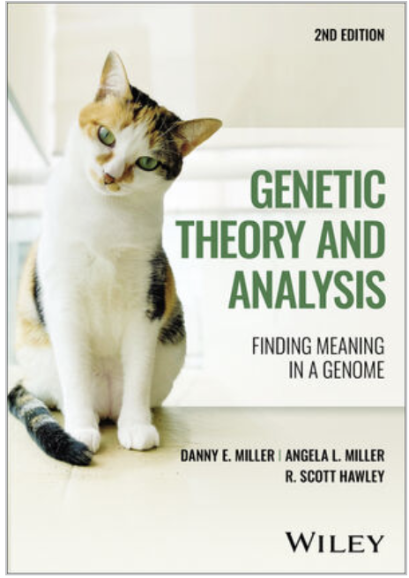
Textbook: The required textbook for MGY340 is Miller, DE, Miller, AL, and R.S. Hawley (2023). Genetic Theory and Analysis: Finding Meaning in a Genome, 2d edn. ISBN: 978-1-394-15628-3 (Wiley Publishing)
link here: Genetic Theory ebook

Genetic Theory and Analysis is an intermediate level genetics book, geared to more advanced undergraduates and beginning graduate students. It has exceptionally clear explanations on how to perform genetic analysis, with lots of hard-won wisdom from a lifetime of doing genetics, strongly held opinions and science stories to keep it interesting. R. Scott Hawley is a geneticist's geneticist (who researches how meiosis works)--and this new edition is an update of a 2009 classic. It is available as both a hard copy textbook and a slightly cheaper ebook.

Assessments & Marking scheme:

Evaluations will be largely centered around data interpretation and problem solving. Short answer questions will assess understanding and usage of precise genetic vocabulary (including nomenclature) in designing experiments, generating scientific models, and conveying thoughts clearly and concisely, a core objective of scientific writing. A non-programmable calculator is allowed. Midterms tests will be held during class time (location TBD). 6-10 short (unannounced) quizzes will take place during the semester (~ 5' of class time) worth 5% of the final grade. We'll drop the two lowest marks in calculating the quiz grade.
- Term test 1 : Monday Oct 6 20%
- Term test 2 : Monday Nov 3 20%
- Assignments (equal value each part) 25%
- Unannounced in-class quizzes 5%
- Final Exam 30%
The final exam will cover the entirety of the material but will emphasize the last third of the course: marks on the final will be distributed approximately 1:1:8 between parts 1, 2, 3.
Late penalty policy: 10% per day. Assignments are not accepted if more than 2 days late. Students with accommodations should not assume automatic 1-week extensions for weekly assignments as this would preclude providing timely feedback to the rest of the class prior to the next assignment submission. Contact your instructor to discuss appropriate accommodations.
Missed term work policy: During the academic term, if you are absent from your studies and unable to complete your course work, declare your absence on Acorn and email your instructor AND the course coordinator ASAP. If you have already used your absence declaration on Acorn for the term, use the U of T Verification of Illness or Injury Form (VOI) , and/or letter from your registrar or accommodation letter from accessibility services to support your request for consideration. Requests for accommodations/retakes will be considered on a case-by-case basis with appropriate documentation. Please note that term work extensions/test retakes will not be considered after feedback on the term work and/or the marks have been released but alternative work may be considered. Refer to Student Absences for helpful links: https://www.artsci.utoronto.ca/current/academics/student-absences
MGY340H1 Course Outline

MGY340 is taught in 3 parts, each with its own assignments and assessments. Each term test (there are two) will only encompass the section immediately preceding it. The final exam will comprise material from the entire course; however, the majority will be from section 3.
Part 1 Learning outcomes: Students will learn to perform genetic crosses in eukaryotic model organisms & analyze the results to characterize mutants. Learners will use schematics to explain the logic of meiotic chromosome segregation and describe how recombination generates distinct gametes. Using data from crosses, learners will determine inheritance patterns, identify phenotypes as deriving from single or multiple gene mutations and sort collections of mutants into complementation groups. Students will learn how to read/write genotypes in commonly used model organisms and be able to compare/contrast the genetic toolkits of yeast, worms, flies and mice, as well as compare/contrast different strategies for generating mutants.
Weeks 1-2: Review of Mendelian inheritance principles with a focus on the experiments (how do we know what we know?) and on using the principles of genetic inheritance (meiosis, segregation, and recombination; genetic linkage; complementation) to characterize mutants. Review of the logic of meiosis--notably the core mechanisms that underlie how cells segregate their chromosomes including how meiotic recombination works and its use in generating genetic maps. Assignments will focus on the use of complementation and segregation tests to characterize mutants with respect to the types of alleles and their modes of inheritance. Textbook chap. 1 & 4. Assignments 1 & 2.
Week 3: Introduction to commonly used eukaryotic model organisms (yeast, worm, fly and mouse) including an overview of organism specific nomenclature, genome structure and databases, experimental toolboxes, genome engineering technologies. Textbook Appendix A (expanded).
Week 4. Introduction to mutant hunts & simple genetic screen design: review of types of mutagenesis and how they lead to different types of mutations that give rise to different classes of alleles (more on this in part 2). Using complementation and segregation tests to identify the number of genes, map genes to chromosomes and to each other. Examples of simple genetic screens in yeast, guided reading of paper(s) as time allows. Textbook chap 1, 2 & 3. Assignment 3.
October 6, 2025: Term Test 1 on part 1 material (20% of final grade)
Note: term tests will take place during regular class time, usually in the learning center (details TBD). Please arrive a few minutes early so that we can start precisely on time.
For test 1: You can bring a non-programmable calculator and a personal 1 page (ie not made using AI), single sided, HANDWRITTEN, "cheat sheet" with whatever you want written on it. The test will be mostly problem solving, so the value of the cheat sheet is more as a study aid than a test aid (i.e. making it is what's helpful to you--hence using AI defeats its purpose). You will need to hand it in with the test.

Part 2 Learning outcomes: students will be able to design simple genetic screens; assign mutants to genes; design and interpret crosses to locate genes on chromosomes; make inferences about the role of a gene from mutant phenotypes.
Week 5: Mutant screens in C. elegans and Drosophila; general design, examples; balancer chromosomes; assessing screen saturation; initial mutant characterization
Week 6: Introduction to genetic interactions; suppression, enhancement; examples
Week 7: Mapping and identifying the gene affected in a mutant; two-factor mapping; multifactor mapping with visible and molecular markers; deficiency mapping; mapping with whole genome sequencing; mutant rescue, RNAi phenocopy
Week 8: Loss-of-function vs. gain-of-function mutations; gene dosage tests; inferring the role of a gene from mutant phenotypes; using existing mutations to obtain new alleles of a gene
November 3, 2025: Term test 2 on part2 material only (20% of final grade)

Part 3 Learning outcomes: students will be able to recognize and interpret genetic interactions; design screens based on interactions; recognize epistatic interactions and interpret them to build models of genetic pathways; interpret mosaic phenotypes to infer focus of action and cell-autonomy or -non-autonomy; design to create new mutants using various genetic tools
Week 9: Genetic interaction analysis; suppressor and enhancer screens; approaches to identifying new genes.
Week 10: Epistasis; building models of genetic pathways
Week 11: Mosaic (clonal) analysis in C. elegans and Drosophila; identifying where the activity of a gene is required; mosaic screens for new mutations.
Week 12: Mouse genetics, mouse mutant screens, reverse genetics, transgenic models, etc.

FINAL EXAM: December Final Assessment Period, Date TBA
While all class material is included in the final exam, the majority focus will be on Part 3 material. The exam will include a ~ 1:1:8 split between parts 1, 2 and 3 of the course.

StarGenetics: We will be using an excellent Mendelian Genetics Simulator created by MIT http://star.mit.edu/genetics/screenshots/index.html for several assignments in Part 1 of the course to give you practical experience in using crosses to determine the mode of inheritance of unknown mutants. You have the option to download the software from Quercus and run it onto your own desktop or access the program through the Sid Smith Computer lab (SSH561). Because StarGenetics is JAVA based, an updated version of JAVA is required -- it's free at https://www.java.com/en/ , and you will also have to reset the permissions to allow it to run (you will see warnings that MIT is considered an "unknown developer"). The files on Quercus are: StarGenetics.exe (executable file) as well a StarGenetics.jnpl (JAVA version that runs on my Mac).

Note: Newer laptops running advanced security systems like Windows 11 or newer Mac's have had issues running the software because the StarGenetics security certificate has expired. If it doesn't work for you--access the software in person or remotely through the Sid Smith Computer lab SSH561 (see below).

In person or remote access to Star Genetics is via the Sid Smith Computer lab (SSH561) https://labs.artsci.utoronto.ca/ . To access in person, you will need to log in using:

1. Your verified UTOR ID. Note, you only need to verify your UTOR ID once. It's quick and easy to do, just navigate here: https://www.utorid.utoronto.ca/cgi-bin/utorid/verify.pl

2. Your password: AS!######### where ### is your student number (as in AS!100100100).

To use remote access (from any machine including tablets), you will need the same verified login/password but you must first be granted access by IIT first (I submit my class list to IIT in late August to be ready for class). Note that if you joined the course AFTER 1 week prior to the first class, you should email Bri (brigitte.lavoie@utoronto.ca) ASAP with your Name, UTORID, Student number and utoronto email. I will request your StarGenetics access on your behalf. As this can take a couple of days (IIT are super busy at the start of term and sometimes there are glitches), it's wise to (1) check that your access works as soon as class starts and (2) promptly email me if you don't have access or registered for the course after September 25.

Troubleshooting: if you have trouble accessing the SSH561 computers remotely:

(1) Re-verify your UTOR ID: https://www.utorid.utoronto.ca/cgi-bin/utorid/verify.pl
(2) If you have access but can't connect to a machine, try a different one on the list. If you still can't connect, SSH561 may be booked for a class or the machine you chose is already in use--you can check the schedule here: http://lab.chass.utoronto.ca/schedules.php. Try again later.
(3) If this fails, contact brigitte.lavoie@utoronto.ca with your name, UTORID, Student number from your Utoronto email so I can verify that I have you in my list and have IIT check that your data has been entered correctly--typos happen. Don't wait until the night before the assignment--IIT is especially busy in September!

Pro Tip. If after doing the Star Genetics assignments in Part 1 you can characterise mutants in exercises 3 or 4 without any prompts telling you what to do, you have successfully learned what StarGenetics was meant to teach you. Try this with your study group & compare answers! Remember to always predict before you cross and reflect on the lessons from the assignments--there are life lessons that will apply to new mutants!

Expectations--how to succeed in MGY340:

Third year marks an important transition in your learning journey. While knowledge assimilation and comprehension are the hallmarks of introductory courses, knowledge application, analysis, and synthesis are the objectives of the more advanced third and fourth year curricula (refer to Bloom's revised taxonomy below--roughly, Yrs1-2 of undergrad (UG) are focussed on remember/understand/apply while Yrs 3-4 increasingly focus on apply/analyze/evaluate with some opportunities to create --> while life as a researcher is all about creating new knowledge).

As students starting MGY340, you should be able to explain Mendel's laws, and master the core genetic vocabulary (genes, alleles, dominance, recessive, segregation, recombination, complementation, suppression and epistasis etc). On Quercus, you will find a list of genetic terms/concepts you should already have seen in HMB265/BIO260--you should be able to explain these simply in your own words and better yet, draw them. Note that your textbook has a helpful glossary! In this class, our focus will be on using these principles to generate and interpret data to characterize mutants (& understand the experiments underlying prior knowledge).

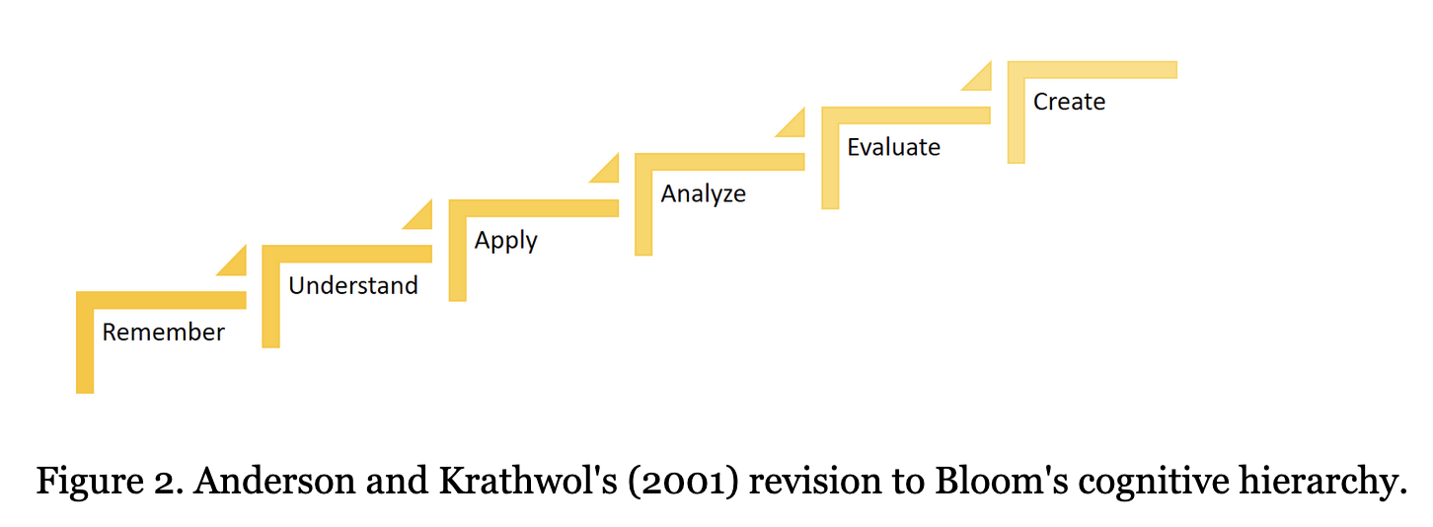
You are here.

During your next two years of UG study, you will also progress from using textbooks and reviews to relying on the primary research literature for information. The data centric/problem-based learning in MGY340 aims to support this transition. Reading the primary scientific literature is challenging for beginners (also for senior scientists researching in a new area), so don't be discouraged by that. Anticipate that it will require sustained effort. It's not enough to know what the conclusions are, as scientists we need to critically assess how those conclusions were derived (and understand the experiments) and importantly, how good the data that underlies them really is (sometimes the data is actually bad!). We want to understand how we know what we know: what were the experiments, why were they done, and how convincing are the results? Were all the necessary controls included? What are their limitations? Are there other possible interpretations? What should we (you) do next (i.e. what are the limits to this knowledge and what are the outstanding questions)? This knowledge then serves as the foundation for designing your own experiments, testing your own scientific models, and expanding our collective understanding of biology.

To succeed in MGY340, you should:

- Attend class (in person) as much as possible: carving out a dedicated time and giving your full attention to the material, your instructor and your classmates makes a huge difference. Expect to develop your notetaking/encoding skills, to ask and be asked questions and to huddle up into groups and participate in coming up with experimental strategies. We will monitor participation through short (unannounced) quizzes worth 5% of the total mark but will knock off your 2 lowest grades.

- Learn actively: take notes that link concepts (not a verbatim transcript), look things up, ask precise questions, practice active recall and spaced repetition, draw out concepts, explain to others, do the assignments (predict outcomes and reflect on what you learned from the data!) because the answer is often less important than the method of getting the answer. Please don't skimp on doing this thinking. The strategies and reasoning you learn (should you start with a male or female mutant to show X-linkage?) are things you take forward.

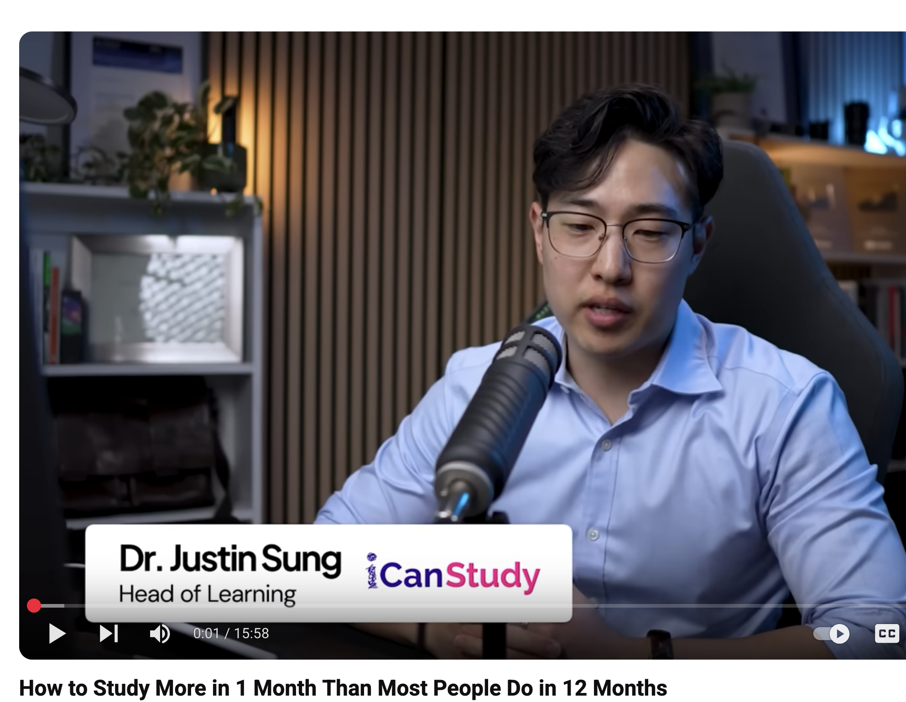
Genetics is like math -- the true value of the assignments isn't the answer you get, but in learning how to approach and solve problems.

Check out this video describing an overall learning strategy that highlights the importance of precisely defining your learning goals (retention and mastery), identifying the gaps in your knowledge and crafting an efficient learning strategy that measures your progress (test yourself!). None of this learning is passive: https://youtu.be/e5WDzbm7fY0?si=1OK6Wmcm1kJaJglt

- Budget your time wisely: per week, expect to devote 3H for in person lectures, ~2-3H review notes/reading the textbook/study group, ~2H/assignment+study group.

Notice that no time is allocated to rewatching recorded lectures--that's because it is a lot more efficient to practice active recall and spaced repetition. Using the textbook readings to complete & expand your notes will give you a deeper perspective on the same concepts (and new examples). Pro Tip: When your textbook says "the critical point is", pay attention. It's flagging a point worth remembering.

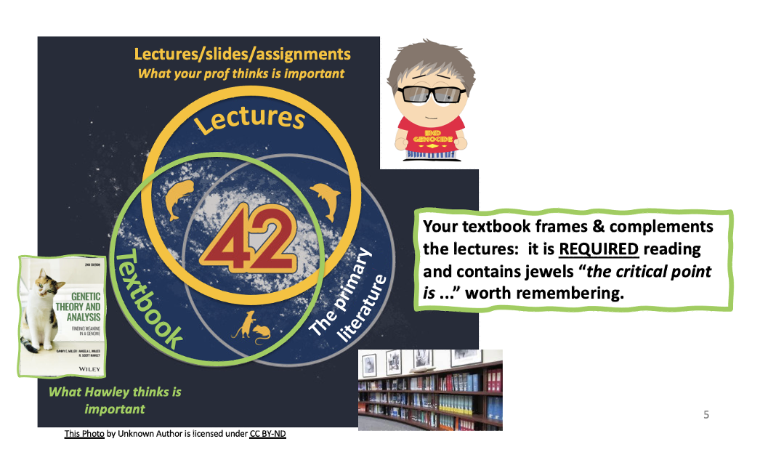
PS For those unfamiliar with "The hitchhiker’s guide to the galaxy" by Douglas Adams, 42 = the answer to life, the universe and everything. Relative to our course content, the Venn diagram overlap (i.e. 42) is the "must know" zone that your instructors and your textbook authors think is critical information for budding geneticists (of course it all comes from the primary literature).

Need a little science humour? Check out the original "Hitchhiker's Guide" BBC radio4 play

- Be proactive: review your notes (+ READ the textbook) after each class, look things up & engage with your classmates. Test yourself by making up questions and answering them over multiple sessions (aka active recall + spaced repetition). Discussion boards, working through your assignments together & explaining things to each other promote stronger problem solving and foster collaborative learning -- Study Groups can be an effective way to find your blind spots. Plus, sustained effort beats last minute binge cramming every single time.

- Please check out the : Centre for Learning Strategy Support, Student Life | Five Keys to Academic Success on Quercus for evidence-based strategies to help you level up your learning! https://q.utoronto.ca/courses/121834

Remember that work piles up quickly and it's very hard to catch up--try not to fall behind. Registered Study Groups can help you stay on track and manage your workload. The class assignments illustrate fundamental genetic principles and provide you with sound experimental strategies. Don't just do as you are told. Reflect on the predictions, the method and the lessons you can apply to new problems/situations. Make up new problems to solve and share them with your classmates. This is the learning you need to take forward.

- Be curious and have fun: read the primary literature to develop your interests/feed your curiosity (Trends in Genetics is a good place to start), or sign up for newsletters from Science or Nature, and the podcast Naked Genetics is fun. Challenge yourself and attend some research seminars to broaden your interests and knowledge base, and discover what fascinates you. Share! Post about interesting papers or talks you attended (or will attend) in the class discussion board.

UT offers a wealth of research talks: the following calendars are a good place to find seminars on campus :

  - MoGen research seminars: https://moleculargenetics.utoronto.ca/seminars
  - Fac of Medicine Research: https://rhse.temertymedicine.utoronto.ca/hearts-calendar

Don't worry that you won't understand 100% of a research talk--that's not the purpose of going. Apply a little courage and go anyway. If you come out of it with an appreciation of a topic you didn't know much about or gleaned one important/useful nugget of information, it has been well worth your time.

Learning & Assessment strategies--help at U of T:


A great resource offered at U of T to help you on your learning journey is the Centre for Learning Strategy Support. There are lots of tips on the importance of self-care, time management and evidence-based learning strategies like active recall and spaced repetition to help you understand how learning happens and exploit that insight to support your learning objectives. Just putting in time is not enough--you need to work smart. (Did you know that forgetting is an essential part of learning?)
If you aren't practicing active recall and spaced repetition as part of your study routine, do visit the Centre for Learning Strategy Support, Student Life | Five Keys to Academic Success on Quercus to help you level up your learning strategies! https://q.utoronto.ca/courses/121834

Recognized Study Groups : Collaborative learning is a proven strategy that supports academic success. RSGs are supported by Arts and Sciences and running / belonging to one is objective evidence of intellectual generosity & engagement, as does being a volunteer notetaker(--more on the importance of this for reference letters later). This not only looks good on your CV, but it's an excellent way to leverage skill sets among your classmates, discuss the material and the assignments, collaboratively define the key concepts to study, make up new problems for the group to solve, plus make like-minded friends (science is a team sport!). MGY340 is a problem-solving course, and like math, genetic analysis benefits from practice.

Importantly, team study can help you find your blind spots (what you don't even know you don't know!), think about the course material from new and different angles, and allow you to practice explaining concepts clearly, deepening your understanding. Working through assignments together allows you to explain to others what you did and why and then check your conclusions with the group. Making up new genetics problems & working through them with your group is a great way to practice all your skills. The following youtube iCan Study video makes a case for Study Groups & provides a defined framework for using them effectively. https://youtu.be/8vDrcQQyHGo?si=7YJZ-DE3rYpmcPu9]

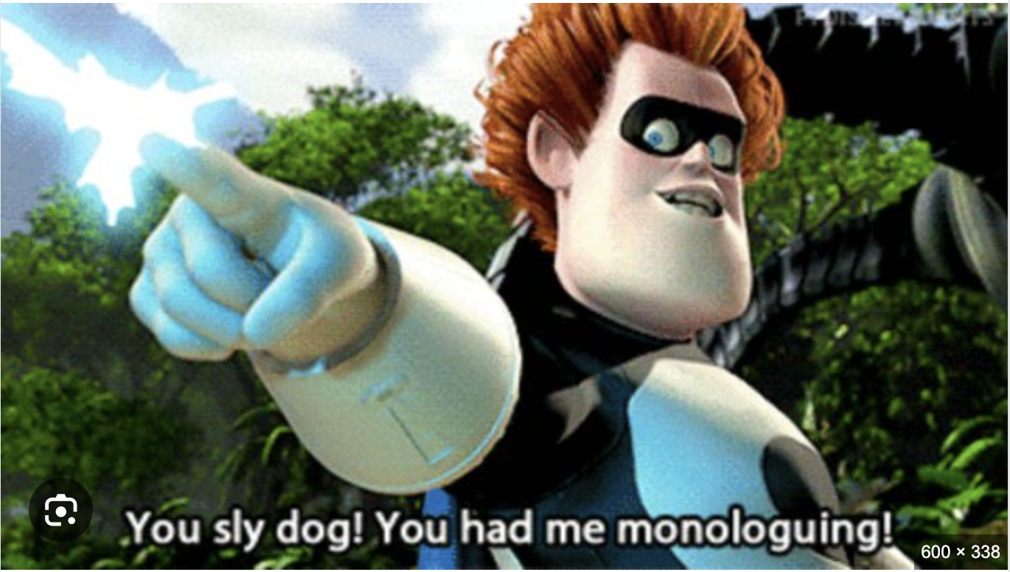
Midterms/Assignments: In high school, you may have been taught that 1 mark = 1 line of text. This no longer applies. In MGY340, a question worth 10 marks better reflects the amount of time to allocate to your answer (which could be just a couple of lines) or the thinking it takes to create a good schematic or an organized strategy for the crosses and experimental predictions, not the amount of verbiage! A good Punnett square/ schematic is often more effective and compelling than a paragraph and takes far less time to write out. Remember to:
- Answer questions precisely and concisely.
- Read questions thoroughly & include everything asked for in your answers (show your data, draw a schematic, include a Punnett square etc). These aren't suggestions, they are requirements.
- Keep it simple--one can always hypothesize that a "hidden second or third or fourth mutation" underlies a phenotype through some convoluted genetic interaction, or that your WT isn't WT after all but harbors unknown random mutations that coincidentally affect your particular phenotype, but is this really likely? There's almost certainly a much simpler answer (and at the bench, we always start with the simplest, most likely hypothesis, not the most far-fetched). While the heart and soul of multiple-choice assessments are the detractors, short answer/problem solving assessments don't work that way. We are not trying to trick you. Don't overthink it!
- When a question asks for a yes or no answer, start with Yes or NO--THEN justify. It's very common for students to contradict themselves in an answer and hope to get marks because they said both yes and no. This seldom works in your favor.
- Practice answering clearly & concisely in your assignments. Punnett square = prediction/hypothesis. Demonstrate clear thinking and correct genetics vocabulary usage. Clearly outline the crosses (who are the parents? genotypes of gametes from mom vs dad?), hypotheses, data, interpretations. Screenshots of tables (Star Genetics) are a good way to show the data or make a table. Take feedback from your TAs to heart, esp. about clarity and using vocabulary correctly! Your friendly (and v. smart) TAs are happy to explain further. Disagree? Ask your instructor.
- On tests, it is safe to assume that we are NOT trying to trick you. The simplest answer (even if multiple steps are needed) is generally the correct one. Don't overthink it!
PS: No extra points will be awarded for extraneous CORRECT information, but marks will be deducted for INCORRECT information.
Personal cheat sheets: Good notetaking skills synthesize information for easy retrieval and distinguish between core concepts vs the examples/details that illustrate them. When a personal "cheat sheet" is allowed on a test, remember that you will likely not have much time (if any) to refer to it. Rather, the value of a cheat sheet lies in the effort it takes to make one. This is why finished cheat sheets shouldn't be made with AI nor shared with others--the learning happens while you are making it. Handwritten diagrams/schematics/ tables are good ways to organize information, highlight relationships and help you see the forest for the trees (the underlying concepts vs the details). There's some evidence (though hardly rigorous) that handwritten vs typed notes work better--certainly schematics are best when hand drawn.
Treat StarGenetics assignments like lab reports. As scientists, our task is to generate straightforward hypotheses (Punnett square = hypothesis), and report on the experiments (crosses) performed to test them (always explicitly state the genotypes of the parents you crossed), the data you obtained (screen shot or copy this from Star Genetics) and the conclusions you drew from the data. Write this out in a simple, clear, stepwise way so that your TA can easily understand what crosses you've performed, what data you obtained and what you concluded from it, just like you would in your lab notebook. Bear in mind that it is our job as scientists to produce, evaluate and communicate our data concisely and precisely. If your TA has to hunt through your assignments to know what experiments you performed, what data you produced and what you concluded from it, you are not making a compelling argument. A good scientist communicates clearly and simply-- practice these skills in your assignments (it will help on the test).

About reference letters: things I wish I'd known as a 3rd year undergrad

Many of you will be considering careers in research, medicine, biotech, education, etc. For most if not all post-grad programs, 2-3 reference letters will be required, and the better someone knows you in a scientific context, the more helpful the letter they can write. Help us get to know you.

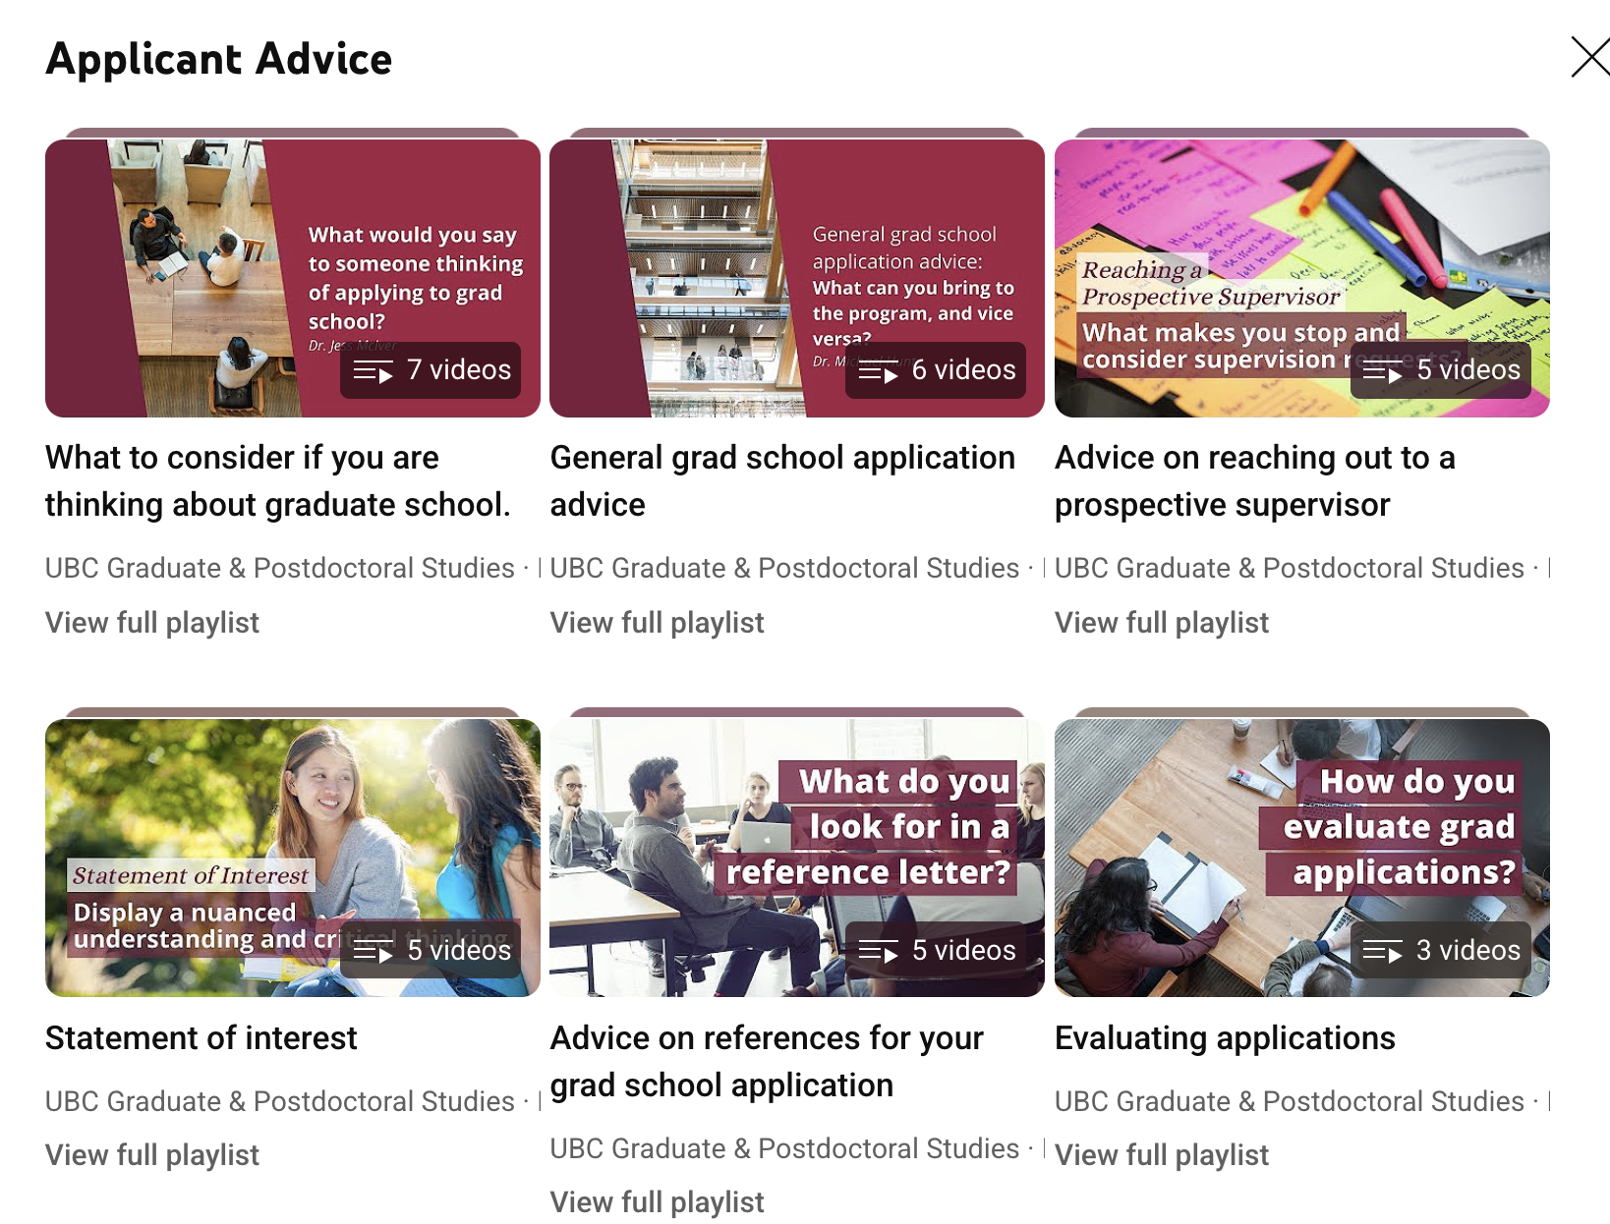
For those of you wishing to continue to graduate school, UBC has created some helpful you tube videos with excellent general advice on applying to grad school. https://www.youtube.com/@universityofbc

Keep in mind that the most compelling letters of recommendation will come from your research advisors during summer or independent research projects. These advisors know you personally, can directly assess skills essential for success in grad school and can discuss your research potential with relevant examples of your professionalism, work ethic, organizational skills, attitude/resilience (experiments can be frustrating and working out the kinks takes grit), ability to learn new things, ability to ask for help when you need it, your experimental skills at the bench, critical data analysis skills as well as your scientific & emotional maturity, communication skills and ability to effectively work in a team. Are you a lab pig or a good lab citizen? A team player that helps others or someone that uses the last of the buffer or finds a piece of broken equipment and leaves it for someone else to sort out? Someone you can count on to do what they say they will do? Respects other people's time and is helpful to others? Works efficiently and well? (and asks when not sure!) Professionalism matters in the workplace, and all this will be discussed in this reference letter so make every effort to be someone who always behaves professionally, shows up on time, respects your colleagues, is conscientious and rigorous, and does what they say they will do.

In contrast, letters from lecturers can comment on very different aspects of your skillset: your engagement with the course material, your overall scientific curiosity, your intellectual generosity towards your classmates (are you a volunteer notetaker? run a study group? participate in discussion boards?) and your academic excellence, but we can't say much about research potential or bench skills, nor is it possible to comment on someone's communication skills if they don't engage with you or the discussion boards. Discussion-based 300 and 400 level courses tend to offer more opportunity for your prof to get to know you, and thus are in a position to write you a helpful letter. Provide them with your CV, your transcript and your Letter of Interest (cover letter you include as part of your grad application)...maybe also some point form version of your relevant interests that speak to your leadership, intellectual curiosity and generosity towards others etc. In class, make an effort to introduce yourself, participate in group discussions, ask questions, be present on discussion boards, engage with your professors during office hours and chat with them when you meet them socially! If you really want to stand out, attend some departmental research seminars -- sit next to one of your profs and make small talk or ask about the seminar or other things on your mind. If you feel too shy to do this, remember that most of us in science feel that way--there's the odd extrovert of course, but most of us are introverts by nature (even your instructors--we have simply gotten better at hiding it). As to research talks: don't limit yourself to topics you already know you are interested in--try to seek out topics you know little about or better, ones what you have never heard of! I discovered my love of transposons that way and it led to a great PhD thesis experience. Immunize yourself broadly against ignorance.

Academic Integrity : When in doubt, please ASK!

"Generally, academic misconduct is any behavior, intentional or otherwise, that gives a student unearned or unfair advantage in academic work over other students."

While every student is responsible for knowing the Code of Behavior on Academic Matters, a helpful (shorter!) list of real academic integrity risks can be found at https://www.academicintegrity.utoronto.ca/perils-and-pitfalls/ . This includes sharing your or others' finished work (including posting on-line to any forum), and the use of generative AI (large language models or LLM) for a marked assessment. Be very aware that LLMs can't distinguish between good data and junk, often make up facts and references, and that submitting any work that isn't your own is an academic offense (nor is it smart to teach a computer to do a job you will want in the future). In MGY340, use of LLMs is not permitted.

A special note about Group work: "If you want to go fast, go alone. If you want to go far, go together."

Science is a team sport. Working with others is a crucial aspect of the skillset every modern scientist must master. Group work was and remains an essential part of my own learning journey--explaining things to others boosts your own learning through active recall, and helps you articulate your thoughts precisely and simply (a very important skill for explaining answers on tests). It also forges important connections with your classmates to help you manage both stress and workloads. Moreover, these classmates may very well end up being your scientific colleagues/collaborators later on, so investing in mutually helpful relationships is worth your time. Working through assignment problems together and making up new ones for your study buddies to solve are integral to mastering the skills you need as geneticists. This type of collaboration helps you find your knowledge blind spots (which you can't do solo), as well as work through more complex problems than you could on your own. To compound the benefits, as much as possible aim to do this face-to-face vs on-line. Go ahead and explain to someone how you answered the question, what you did or where they are going wrong, but everyone must then go away and use that information to redo the analysis/complete their own assignments (which everyone must do for the test anyway). Where trouble arises is when on-line sessions are recorded: the use of social media and electronic communication (and the convenience of sharing documents and screens) carries risk because it is just too easy to copy/paste/take a screenshot and stressed-out people pressed for time can be tempted to take academically dubious shortcuts. The UT Academic Integrity website notes that: "Students studying in groups should be careful to safeguard their own work, to avoid sharing copies of finished work or previous assignments, and to be cautious about transmitting electronic copies of their work to other students." It is never OK to record/copy/paste answers that are not your own work (even if you gave ChatGPT the prompts). Similarly, sharing your or someone else's completed work in any forum facilitates copying and is also therefore a violation. Should you ever suspect that someone has shared or is using your work without attribution, contact your instructor. Your scientific integrity is precious. I could never write a reference letter for someone who cheated in my class: seeking and speaking truth is at the essence of being a scientist.

FYI: Recording Lectures/Photographing slides without permission is also an academic violation.
From https://www.academicintegrity.utoronto.ca/smart-strategies/recording-lectures/
"If a student wishes to tape-record, photograph, video-record or otherwise reproduce lecture presentations, course notes or other similar materials provided by instructors, he or she must obtain the instructor’s written consent beforehand. Otherwise, all such reproduction is an infringement of copyright and is prohibited. In the case of private use by students with disabilities, the instructor’s consent will not be unreasonably withheld. Students with disabilities who request accommodation should contact Accessibility Services on their campus."

If this seems hard, bear in mind that it is necessary practice for your future careers as independent researchers. In class, you have the slides, the textbook, your classmates and your instructor to help you fill any gaps. At scientific conferences or in research seminars, you are on your own! No handouts nor slides are provided, nor are you allowed to record/photograph anything--you rely solely on your notetaking skills.

Final word:

Congratulations on leveling up in your learning journey! Since you've made it this far in reading the syllabus, well done! As a reward, email Bri with the words House Hippo in the header to be included in a draw for a prize. Remember that third year is a transformational year -- it's a big step up that will excite you and challenge you and frustrate you and occasionally make you doubt yourself. This is totally OK. It is the typical learning journey. The hard stuff is in fact where the most fun is to be had, and the most perplexing puzzles the most satisfying to solve (assuming there is a solution--not actually a given in real life). Embrace making mistakes, adopt evidence-based study techniques, get enough rest and be kind to yourself and your fellow learners (because we all fail at some point). Learn to trust your instincts (you know more than you think) and bravely seek out the gaps in your genetics foundation and address them. Be proactive--recognize when to need support and seek help earlier than later. Make peace with the fact that the life of a researcher is one of constantly learning new things, which makes you (me) feel like we are perpetually stupid (well, ignorant anyway) , and that this is why it's actually fun. In many important ways, third year begins to prepare you for what research really is. You will work hard and it's worth it: the knowledge foundation you build now will support everything you learn later and primes you for the next step of creating new knowledge. We're excited to meet you and are committed to helping you master what Hawley satisfyingly calls "the proper doing of genetics".

C U in class! Cheers,
Bri, Julie and Jeehye
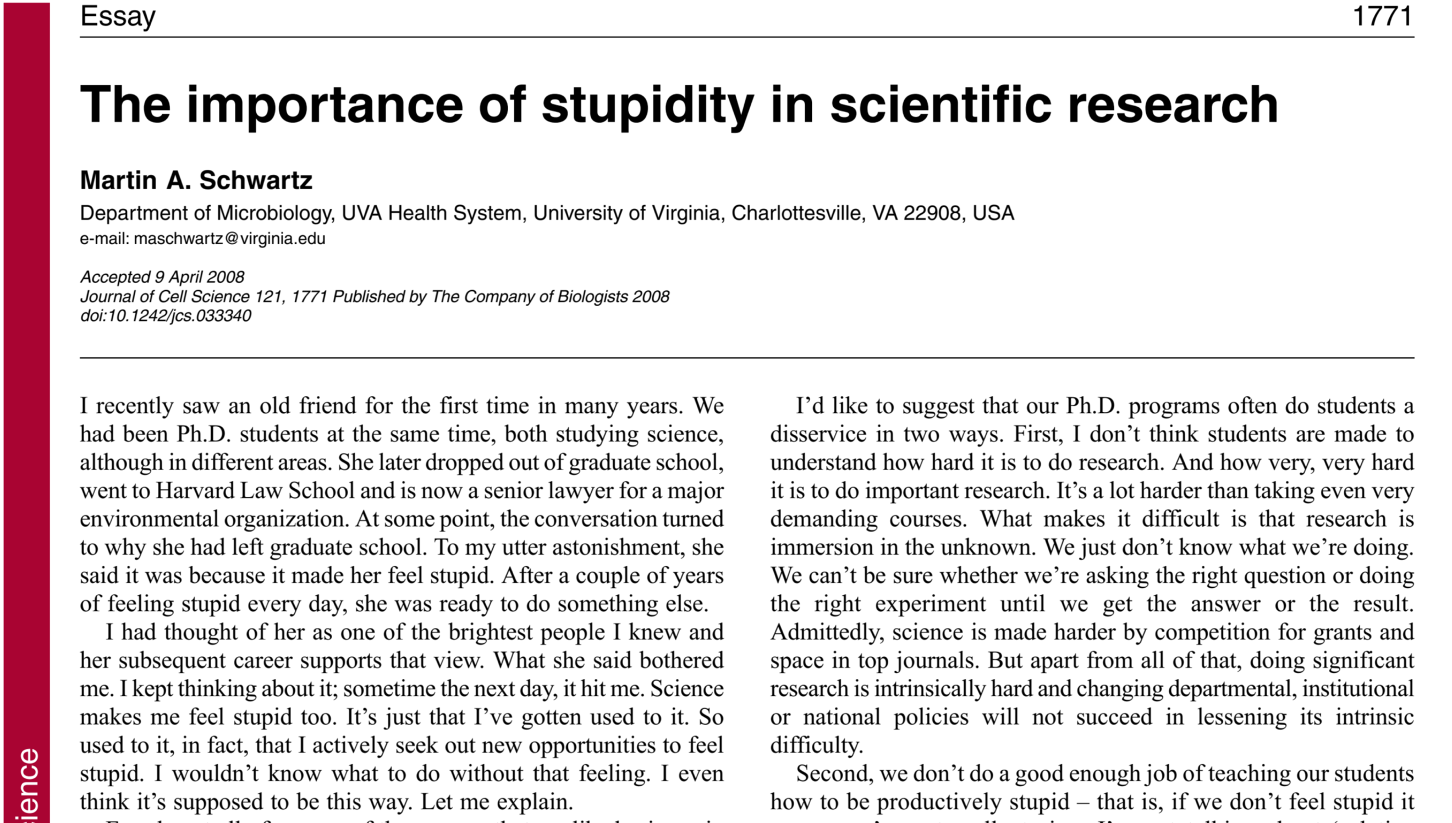

Signing off with a link to one of my favorite essays on

"The Importance of Stupidity in Scientific Research" by Martin A Shwartz (2008) J. Cell Sci Jun 1;121(11):1771. doi: 10.1242/jcs.033340. PMID: 18492790

